

Functional Area: CSA Portal – Locate MTM Account

Screen Specifications

Document History
Version | Date | Description | Name
0.1 | 15/02/2006 | Initial draft | Nicholas Cole
0.2 | 19/02/2006 | Reviewed with the business.  Screens for Login, Locate Customer and Delete MTM account have been baseline. | Nicholas Cole
0.3 | 19/02/2006 | View Audit History Added | Nicholas Cole
0.4 | 23/02/2006 | Split out from whole system screen specification.  Baseline by Business | Nicholas Cole
0.5 | 23/03/2006 | BAN and MTM username validation updated | Nicholas Cole
0.6 | 24/03/2006 | Business data to domain model mapped  Ban validation added  Search notes regarding single or multiple fields for locate MTM account added. | Alexander Fyodorov  Nicholas Cole  Nicholas Cole

1.1.1 Screens 3
1.1.1.1 Screen – Locate Customer 3
1.1.1.2 Screen – Left Hand Menu Tile 6
1.1.1.3 Domain Model 7

Screens

Screen – Locate Customer
The purpose of this screen is for user to locate the Customer by one of three ways: their Username, CTN or BAN.

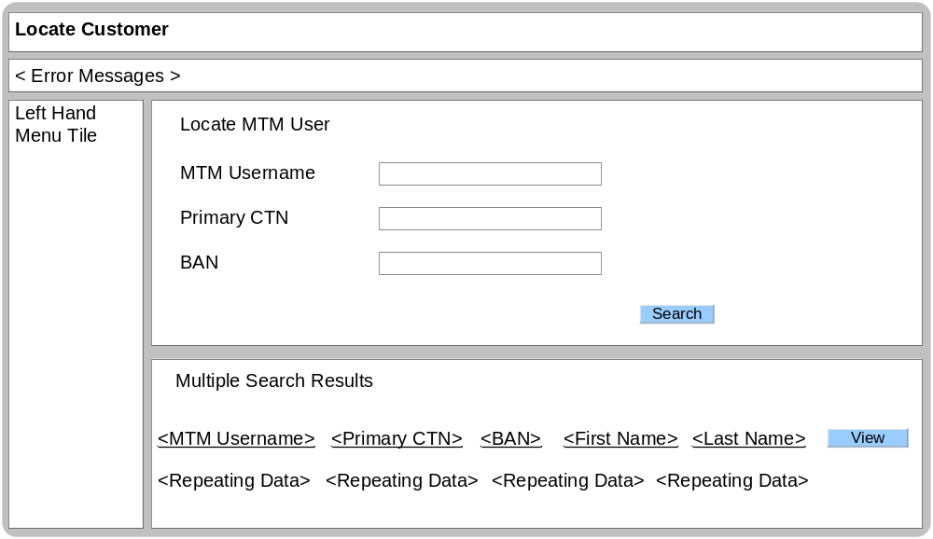

Business Logic Content
Name | Type | Description/Condition
Locate Customer | Screen Title | The title of the screen
Error Messages | Dynamic Text | The Error Messages will be displayed if any of the validation rules are not met.  If either the MTM username, CTN or BAN fields are empty:  Error Message = “Either a CTN, BAN or username must be entered.”  If MTM Username length < 2 OR > 20 chars:  Error Message = “Not a valid MTM Username.”  If CTN length <> 11 chars, OR CTN has non-numeric chars, OR CTN does not start with ‘07’:  Error Message = “Not a valid CTN.”  If BAN format is invalid (Min =6 characters. Max =9 characters or not numeric characters)  Error Message = “Not a valid BAN.”  If no users found:  Error Message = “No users found.”
Left Hand Menu Tile
Described within section 1.1.1.2
Locate MTM User
This tile is always displayed on the Locate Customer Screen.
A combination of 1 or many search fields can be used to search for a MTM account. If 2 fields have been entered then both sets of search criteria must be used.

MTM Username | Data entry field | The MTM username of the account which is being located.  Either the MTM Username or Primary CTN or BAN field must be completed for a search to take place.  Default value is empty on entry  See common validation document for MTM username validation.  An asterisk character can be used as a wild card search parameter at the end of the string only.
Primary CTN | Data entry field | The primary CTN of the account which is being located.  Either the MTM Username or Primary CTN or BAN field must be completed for a search to take place.  Default value is empty on entry  Min = 11 characters. Max = 11 characters
BAN | Data entry field | The BAN associated to the account which is being located.  Either the MTM Username or Primary CTN or BAN field must be completed for a search to take place.  Default value is empty on entry  Min =6 characters. Max =9 characters  Numeric characters only
Multiple Search Results
This tile will only be displayed when multiple search results are retrieved.
<<< REPEATING DATA BEGIN
<MTM Username> | Dynamic Text | The MTM username of the account which has been located.  This is mandatory when multiple search results are displayed.
<Primary CTN> | Dynamic Text | The primary CTN of the account which has been located.  This is not mandatory and null values are allowed when multiple search results are displayed.
<BAN> | Dynamic Text | The BAN associated to the account which has been located.  This is not mandatory and null values are allowed when multiple search results are displayed.
<First Name> | Dynamic Text | The first name of the user which has created the MTM account.  This is mandatory when multiple search results are displayed.
<Last Name> | Dynamic Text | The last name of the user which has created the MTM account.  This is mandatory when multiple search results are displayed.
REPEATING DATA END >>>

Links
Name | Destination | Description/Condition
Search | MTM Profile | The MTM profile screen will be displayed when a single MTM account has been located.
Search | Locate Customer | The locate customer screen will be displayed when multiple MTM accounts have been located
Search | Locate Customer | The locate customer screen will be displayed when field validation has failed or no MTM accounts have been located.
View | MTM Profile | The MTM profile screen will be displayed when the located MTM account has been selected.

Validation
Name | State / Response
MTM Username,  Primary CTN,  BAN | If a search is submitted without values entered in either the MTM Username or Primary CTN or BAN fields, then an error message must be displayed.

Screen – Left Hand Menu Tile
After the user successfully logged into the CSA Portal, a left hand menu will be present on all the screens. The following section describes the behavior of the left hand menu tile.

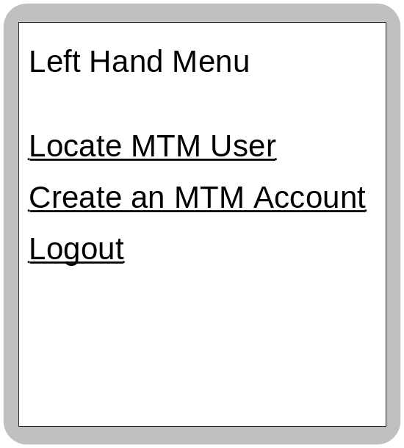

Business Logic Content
Name | Type | Description/Condition
Left Hand Menu | Screen Title | The title of the screen

Links
Name | Destination | Description/Condition
Locate MTM User | Locate Customer Screen | Leads the user to the ‘Locate customer’ screen to carry out a MTM user search.
Create an MTM Account | Create an MTM Account | Leads the user to the ‘Create an MTM account’ screen where a new MTM account can be created.
Logout | CSA Portal Login | The CSA Portal Login screen will be displayed and the users login session will be destroyed.

Validation
None

Domain Model

Field | Domain Model Name
MTM Username | MTMUser.User.userid
Primary CTN | MTMUser.MTMUserProfile.UserProfileMobile.isCommunicationCTN
BAN | MTMUser.MTMUserProfile.BillingAccount.accountNumber
First Name | MTMUser.Person.firstName
Last Name | MTMUser.Person.lastName

